5.66: The elevator’s acceleration is:
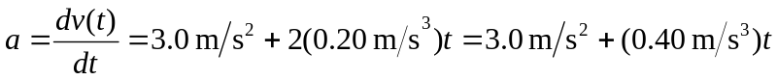
At . From Newton’s Second Law, the net force on you is
